Everything for $5.00




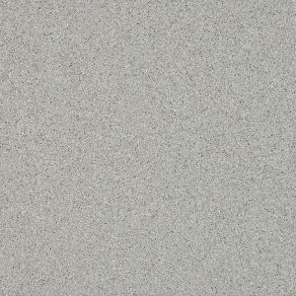


APPAREL AVALIABLE AT DACOTAH BANK-ROSLYN
OR
EMAIL: Shannon Schmidt skadmin@venturecomm.net

